Test results food classification

# One function multiple colours:

For these tests we created one function which detected purple,red, yellow and green as seen below:

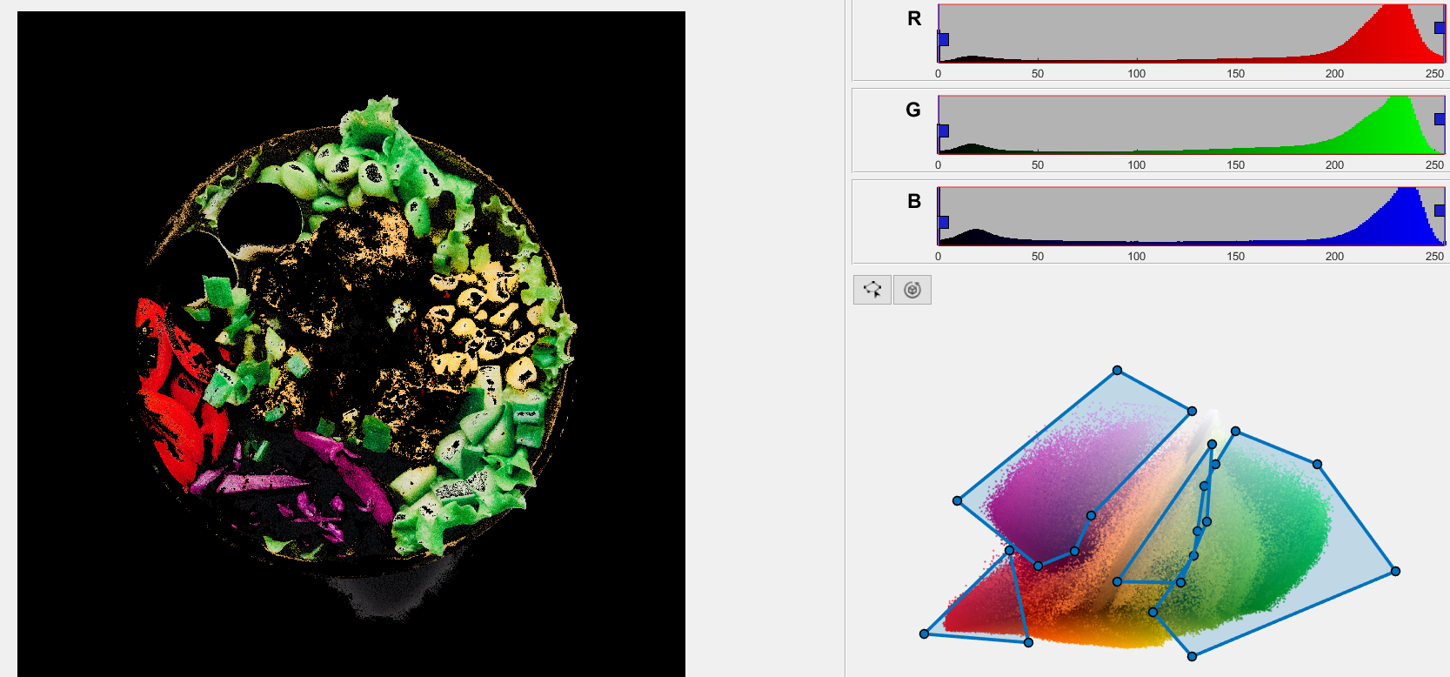

Figur 1 Snapshot from the Image Threshholder

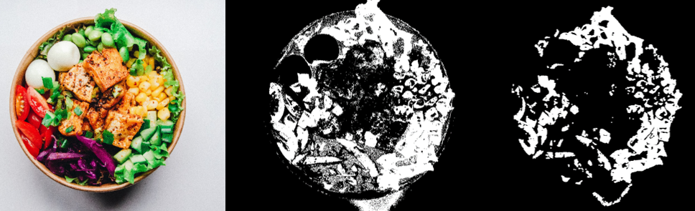This function yielded the following result:

Figur For variedSalad